Yeshwantrao Chavan College of Engineering
Project Preliminary Investigation Report

Name of Department:
Computer Technology

Name of Project Guide:
Prof.N.U.Sambhe

Name of Project Co - Guide (if any):
Prof.P.S.Shete

Students Details:

Roll No. | Name of Student | Email ID | Mobile No.
31 | Vedika Peshane | 22070417@ycce.in | 7389468468
39 | Aditya Bhone | 22071368@ycce.in | 7385481709
47 | Atharva Pophali | 22070518@ycce.in | 8698558933
48 | Atharva Fukey | 22071175@ycce.in | 8010154438
57 | Hariom Balang | 22071070@ycce.in | 8010911255
103 | Kiran Wande | 22070185@ycce.in | 9322481549

Title of the Project:
Advance Monitoring and Control Mechanism for Electric vehicle charging station using Machine learning

Area of Project Work:
Machine Learning

Problem Statement:
Predicting Charger Current Output: The need for a machine learning system to predict the optimal current output at EV charging stations, ensuring efficient charging while maintaining operational stability.

Fault Detection and Correction: Addressing the challenge of real-time fault detection in charging equipment, with an automated control mechanism to correct faults or alert authorized personnel if correction is not possible.

Optimizing Charging Operations: Enhancing charging station performance by dynamically optimizing charging parameters to prevent load imbalances, reduce downtime, and ensure a seamless and efficient user experience

Prior Art (Patent Search):

Patent Application No. | Title of Patent | Existing Solutions (Abstract of Patent)
 | Vehicle power source device and its method for diagnosing faults | The invention provides a vehicle power source device with fault diagnosis capabilities to simplify identifying issues in electrical paths during charging and power delivery.

 | Power grid aware machine learning device | A system uses machine learning to optimize the operation of electrical devices by forecasting power source status and generating operational rules, enhancing energy efficiency, grid stability, and cost savings.

Literature Review:

Title of Paper | Details of Publication with Date and Year | Literature Identified for Project
Data-Driven Charging Demand Prediction at Public Charging Stations Using Supervised Machine Learning Regression Methods | 2020

Automatic Fault Detection And Analysis Of Electric Vehicle Charging Station By Machine learning | 2024
Data-driven Short-term Electric Vehicle Charging Station Demand Forecasting | 2024
Machine Learning-based Electric Vehicle User Behavior Prediction | 2023

Quality of Service Evaluation and Forecast for EV Charging Based on Real-World Data. | 2023
Optimizing Electric Vehicle Charging Station Placement in Urban Areas: A Data-Driven Approach. | 2023
Enhancement of Charging Efficiency of Batteries for Electric Vehicles: Review. | 2023
Design and Development of Smart Charging Infrastructure for Electric Vehicles | 2023
Electric Vehicle Charging Behavior Prediction using Machine Learning Models | 2022
Machine Learning for Solving Charging Infrastructure Planning: A Comprehensive Review | 2022

Current Limitations

- Inaccurate Demand Forecasting – Traditional models fail to account for real-time fluctuations, leading to inefficient energy distribution.
- Grid Overload & Energy Inefficiency – Sudden demand surges cause power grid strain, increasing operational costs and energy wastage.
- Slow & Unoptimized Charging – Fixed voltage/current delivery results in longer charging times and battery degradation.
- Lack of Fault Detection & Anomaly Management – Existing systems fail to detect faults in real time, leading to station downtime and higher maintenance costs.
- Limited Scalability & Adaptability – Traditional models struggle to scale with increasing EV adoption and adapt to new charging behaviors.

Proposed Solution

- Accurate Demand Forecasting – Use XGBoost, SARIMAX, and Random Forest for real-time energy prediction.
- Smart Grid Load Management – Implement K-Means clustering & Reinforcement Learning for efficient energy distribution.
- Optimized Charging Speed – Develop AI-driven dynamic voltage/current control to reduce charging time & protect battery health.
- Real-Time Fault Detection – Deploy SVM & Random Forest classifiers for anomaly detection and predictive maintenance.
- Scalable & Adaptive System – Use cloud-based architecture & continuous learning models to handle future EV growth.

Objectives and Scope of Work

Objectives:
- Predict EV Charging Demand – Use machine learning models (XGBoost, Random Forest, SARIMAX) to forecast energy demand.
- Optimize Energy Distribution – Implement smart grid integration for efficient load balancing and prevent grid overload.
- Enhance Charging Efficiency – Develop an AI-driven system for dynamic voltage and current adjustment to reduce charging time.
- Enable Real-Time Monitoring & Fault Detection – Deploy anomaly detection models (SVM, Random Forest) for hardware issue identification.
- Ensure Scalability & Adaptability – Use cloud-based architecture and continuous learning models to support growing EV adoption.

Scope of Work:
- Data Collection & Preprocessing – Gather historical and real-time EV charging data, clean and preprocess it for model training.
- Machine Learning Model Development – Train XGBoost, Random Forest, SARIMAX, and K-Means for demand prediction and optimization.
- Grid Integration & Load Management – Implement smart energy distribution and demand response mechanisms to prevent grid overload.
- Real-Time Monitoring & Fault Detection – Deploy anomaly detection models (SVM, Random Forest) for charging station diagnostics.
- System Deployment & Scalability – Use cloud computing for multi-station management and continuous model updates.

Feasibility Assessment:
- Expected Outcomes of the Project

- Accurate EV Charging Demand Prediction – Machine learning models provide real-time energy forecasting to optimize grid performance.
- Optimized Grid Load Management – Smart energy distribution prevents grid overload and reduces electricity costs.
- Faster & Adaptive Charging – AI-driven dynamic voltage/current control enables efficient and safe charging.
- Real-Time Fault Detection & Alerts – Automated anomaly detection ensures minimal downtime and reduced maintenance costs.
- Scalability & Future Adaptability – A cloud-integrated, AI-powered system that evolves with growing EV adoption.

- Innovation Potential
- AI-Powered Charging Route Optimization – Uses real-time traffic, battery levels, and station availability to suggest the fastest & most efficient charging route.
- Wireless & Ultra-Fast Charging – Development of inductive wireless charging and high-power ultra-fast charging stations to reduce downtime.
- IoT-Enabled Predictive Maintenance – Smart sensor-based fault detection can automate repairs & prevent station failures before they occur.
- Renewable Energy Integration – Smart solar- or wind-powered EV charging stations with AI-driven energy storage management.
- Swappable Battery Technology – Instead of waiting for charging, users can swap depleted batteries at stations for fully charged ones in seconds.
- Autonomous EV Charging Stations – Self-operating robotic arms to charge EVs without human intervention, increasing efficiency in public charging.

- Task Involved
- Data Collection & Preprocessing – Gather historical & real-time data, clean and prepare it for model training.
- Machine Learning Model Development – Train XGBoost, Random Forest, SARIMAX, K-Means for demand prediction & optimization.
- System Integration – Develop real-time dashboards and integrate models with grid management APIs.
- Real-Time Fault Detection – Implement SVM & anomaly detection models to monitor charging faults & hardware issues.
- Energy Optimization – Use Reinforcement Learning & K-Means for smart energy distribution & load balancing.
- Deployment & Testing – Deploy models on cloud infrastructure, test accuracy, and optimize efficiency.
- Scalability & Future Adaptability – Automate model updates and ensure long-term growth for increasing EV adoption.
- Expertise Required
- Machine Learning & Data Science – Knowledge of XGBoost, Random Forest, SARIMAX, K-Means for demand prediction & optimization.
- Power Systems & Grid Management – Understanding of smart grid integration, load balancing, and energy distribution.
- Software Development & Backend Engineering – Proficiency in Django, FastAPI, and cloud computing for system deployment.
- IoT & Embedded Systems – Experience with Raspberry Pi, MQTT, and real-time sensor data processing.
- Cybersecurity & Network Communication – Securing real-time data transmission & protecting charging station infrastructure.
- Front-End Development – Expertise in React.js, Django Templates, and WebSockets for real-time dashboards.
- Cloud & DevOps – Managing AWS, Azure, or Google Cloud for scalable data storage & machine learning model deployment.
- Facilities Required
- Hardware Infrastructure – Raspberry Pi, IoT sensors, smart meters, and EV charging stations for real-time data collection.
- Computing Resources – High-performance servers, GPUs, or cloud services (AWS, Azure, Google Cloud) for ML model training and deployment.
- Software & Development Tools – Python, Django, FastAPI, TensorFlow, Scikit-learn, PostgreSQL, MongoDB for backend and ML development.
- Networking & Communication – MQTT protocol, WebSockets, and APIs for real-time data exchange between devices and cloud servers.
- Testing & Simulation Environment – Power grid simulators, energy management software, and smart charging test beds for system validation.
- Storage & Data Management – Cloud databases, local storage, and distributed data handling for large-scale EV charging data.
- Security & Authentication Systems – SSL encryption, OAuth, and cybersecurity tools for protecting real-time communication and transactions.

Milestones and Time Plan

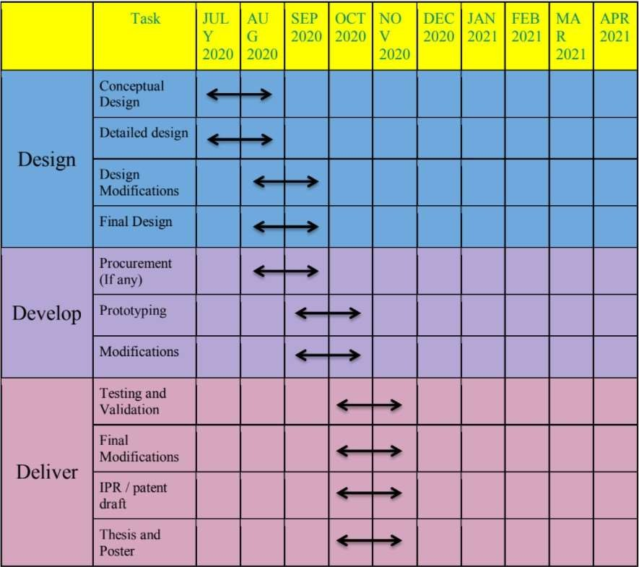

Name and Signature of Project Guide Signature of HOD

